ASSIGNMENT-1 HOME AUTOMATION

Make a Smaít Home in ľinkeícad, using 2+ sensoís, Led, Buzzeí in single code and ciícuit.

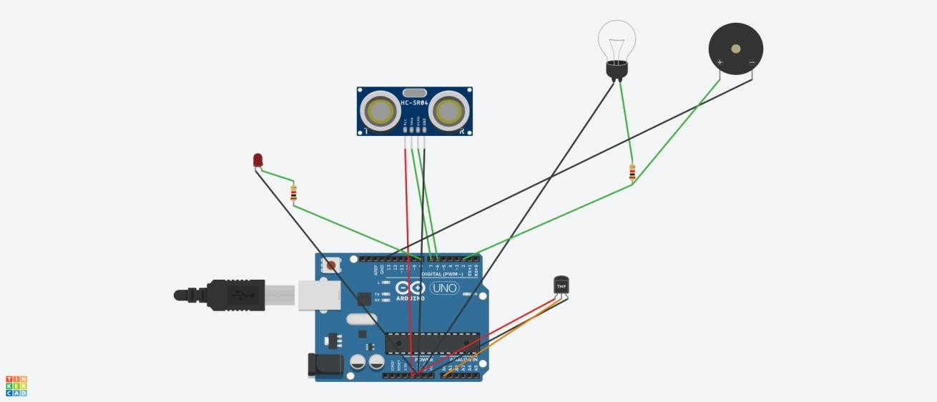

Code:

// C++ code #define t 7

#define e 6

#define bulb 2

void setup()

{

Serial.begin(9600); pinMode(t,OUTPUT); pinMode(e,INPUT); pinMode(12,OUTPUT); pinMode(bulb,OUTPUT);

}

void loop()

{

//ultrasonic sensor digitalWrite(t,LOW); digitalWrite(t,HIGH);

delayMicroseconds(10); digitalWrite(t,LOW);

float dur=pulseIn(e,HIGH); float dis=(dur/2)\*0.0343; Serial.print("Distance is: "); Serial.println(dis); if(dis<100){ digitalWrite(bulb,HIGH);

}

else{ digitalWrite(bulb,LOW);

}

//Temperature Sensor double a= analogRead(A0);

double temp=(((a/1024)\*5)-0.5)\*100; Serial.print("Temp Value: "); Serial.println(temp);

delay(1000);

//LED ON

if(temp>=100)

{

digitalWrite(8,HIGH);

}

//LED OFF

if(temp<100)

{

digitalWrite(8,LOW);

}

}